Adaptive Cost Shaping for 3D Path Planning:
A Hybrid A* Approach with Neural Cost Modulation

Genti Progri$​^{1}$
$​^{1}$University of Elbasan, genti.progri@uniel.edu.al
Abstract
This paper presents a comprehensive study of adaptive cost shaping integrated into classical A* search for 3D path planning. We propose a novel adaptive lambda strategy where the cost modulation factor dynamically adjusts based on learned environmental risk estimates. The framework maintains the optimality guarantees of A* while leveraging a neural environment model trained via backpropagation to predict obstacle probabilities with validation accuracy up to 100%. Extensive experiments across 11 environment configurations (structured, unstructured, and mixed) demonstrate that adaptive lambda achieves up to 17.6× speedup compared to fixed lambda in feasible environments (e.g., 0.319s vs 5.602s in empty environments), while maintaining optimal path length. In infeasible environments, adaptive lambda shows 1.4–1.6× slowdown versus baseline, confirming our theoretical analysis that learned local cost models cannot detect global infeasibility—a structural limitation. Results are validated over multiple runs with statistical aggregation, and all code and models are open-sourced for reproducibility.
Keywords: Path Planning, A* Search, Cost Shaping, Neural Networks, 3D Navigation, Adaptive Algorithms

Introduction
Path planning in three-dimensional environments is a fundamental challenge in robotics, autonomous navigation, and simulation-based decision systems. Classical algorithms such as A* provide optimality guarantees under static cost assumptions but often fail to incorporate environmental uncertainty and learned risk representations [1]. The core limitation of traditional A* lies in its reliance on hand-crafted cost functions that cannot adapt to the underlying structure of the environment or account for perceptual uncertainty.
Recent developments in learning-based motion planning have introduced cost shaping techniques that adjust heuristic influence during search [2, 3]. These approaches aim to improve computational efficiency by guiding the search toward promising regions using learned environment models. However, the trade-off between computational efficiency and adaptability remains poorly understood, particularly in 3D discrete spaces where the branching factor is large and environmental complexity varies significantly.

1.1 Research Gap
Existing cost shaping methods fall into two main categories:
- Fixed-weight approaches that apply a constant penalty factor to learned costs [4, 5]
- Task-specific approaches that require retraining for each new environment type [6, 7]
Both categories share a critical limitation: they assume that the optimal cost modulation factor is constant across all regions of the environment. In reality, the utility of learned risk estimates varies spatially—some regions are well-understood (high confidence), others are uncertain (medium confidence), and others are confidently predicted as obstacles (high probability). An effective cost shaping strategy should adapt to this spatial variability, applying stronger modulation in uncertain regions and weaker modulation where the model is confident.

1.2 Our Contribution
This work addresses this gap by proposing an adaptive lambda strategy that dynamically modulates the influence of a learned environment model based on local obstacle probability estimates. Unlike fixed-weight methods, our approach automatically adjusts the cost penalty using a quadratic modulation function $λ(n)=λ_{0}⋅(1-f_{θ}(n))$, which penalizes uncertain regions most heavily while preserving the structure of confident predictions. This design is motivated by information theory: the maximum benefit of cost shaping occurs precisely where the learned model is most uncertain ($f_{θ}(n)≈0.5$), and the minimum benefit occurs where the model is certain ($f_{θ}(n)≈0$ or $f_{θ}(n)≈1$).
This investigation compares three planning strategies: baseline A* (no cost shaping), fixed $λ$ A* (static weighting), and adaptive $λ$ A* (dynamic weighting). Our contributions are:
- A unified 3D experimental framework with 8 structured/unstructured environment types and 3 mixed configurations, enabling systematic evaluation across diverse scenarios.
- A neural environment model trained via backpropagation achieving validation accuracy up to 100%, demonstrating the effectiveness of gradient-based optimization for environment modeling.
- Theoretical analysis of why adaptive strategies fail in infeasible environments—a structural limitation, not implementation-specific—providing practical guidance for practitioners.
- Empirical demonstration that adaptive lambda achieves up to 17.6× speedup compared to fixed lambda in feasible environments, while maintaining optimal path length, and shows 1.4–1.6× slowdown in infeasible environments, confirming our theoretical analysis.

Related Work

2.1 Classical Path Planning
Classical path planning algorithms have been extensively studied in robotics and artificial intelligence. A* [1] remains the gold standard for discrete grid-based planning due to its optimality guarantees when using admissible heuristics. Variants such as D* Lite [6] and LPA* [6] address dynamic environments, while RRT [7] and PRM [8] scale to continuous spaces. However, these methods assume perfect knowledge of the environment and cannot incorporate uncertainty or learned risk representations. The optimality guarantees of A* come at the cost of computational expense in high-dimensional spaces, motivating the development of heuristic search with learned guidance.

2.2 Learning-Based Motion Planning
Recent years have seen significant interest in integrating learning into motion planning pipelines. Levine et al. [3] demonstrated end-to-end training of visuomotor policies for robotic control, while Silver et al. [12] showed that deep neural networks can guide search in complex domains like Go. In the planning literature, Gupta et al. [14] introduced cognitive mapping and planning for visual navigation, learning spatial representations from raw sensory data.
Several approaches have specifically addressed cost learning:
- Value Iteration Networks (VIN) [15] learn to plan by embedding value iteration within a differentiable neural network, enabling end-to-end training of planning-aware representations.
- Neural A* Search [2] learns a heuristic function that estimates the distance to the goal, improving search efficiency while maintaining optimality through admissible heuristics.
- Learning Sampling Distributions [16] uses learned models to guide sampling-based planners in continuous spaces, reducing the number of samples required.
However, these methods typically learn a single model that is fixed after training and applied uniformly across environments. They do not adapt their guidance strategy based on the local characteristics of the environment or the uncertainty of the learned model.

2.3 Cost Shaping and Heuristic Guidance
Cost shaping modifies the search objective to incorporate domain knowledge or learned risk estimates. The fundamental challenge is maintaining optimality guarantees while improving computational efficiency. Early work on heuristic search with weighted costs showed that inflating the heuristic can speed up search at the cost of optimality.
More recent approaches have proposed learning cost functions from demonstrations or environmental data:
- Inverse Reinforcement Learning (IRL) learns cost functions from expert trajectories, enabling planning that mimics expert behavior.
- Adversarial Inverse Reinforcement Learning extends IRL to high-dimensional spaces using GANs.
- Cost Learning from Experience uses historical planning data to learn cost functions that reflect navigational preferences.
The most relevant work to our approach is cost shaping with learned obstacle probabilities [9, 10], where a learned model predicts the likelihood of occupancy and the search cost is modified accordingly. However, these methods use a fixed penalty factor $λ$ that is constant across all nodes. This is suboptimal because the learned model’s predictions vary in confidence—some predictions are highly certain, others are ambiguous. A fixed penalty applies the same modulation regardless of prediction quality, potentially over-penalizing confident predictions or under-penalizing uncertain ones.

2.4 Adaptive Mechanisms in Search
Adaptive mechanisms [11] have been explored in various search contexts:
- Dynamic weighting adjusts the heuristic weight during search based on the current search depth or expansion count.
- Adaptive A* [11] learns heuristic values during search to improve efficiency in repeated planning tasks.
- Anytime A* [11] produces a suboptimal solution quickly and refines it when time permits.
However, these approaches adapt based on search progress rather than the quality of learned predictions. They do not exploit the structured uncertainty inherent in learned environment models.

2.5 Summary of Contributions
Table 1 summarizes how our approach distinguishes itself from the existing literature. While previous work has explored learned heuristics and cost functions [2, 15, 16], none have introduced an adaptive cost shaping mechanism that responds to the spatial distribution of model uncertainty. Furthermore, our theoretical analysis of failure modes in infeasible environments provides practical guidance that is absent from prior work [9, 10].
Feature | Classical A* | Neural A* [2] | Fixed λ [21] | Our Method
Optimality Guarantee | ✓ | ✓ | ✓ | ✓
Learned Heuristic | ✗ | ✓ | ✗ | ✗
Learned Cost | ✗ | ✗ | ✓ | ✓
Fixed Weight | N/A | N/A | ✓ | ✗
Adaptive Weight | ✗ | ✗ | ✗ | ✓
Spatial Uncertainty Exploitation | ✗ | ✗ | ✗ | ✓
Backpropagation Training | ✗ | ✓ | ✗ | ✓
Theoretical Failure Analysis | ✓ | ✗ | ✗ | ✓
Table 1 : Comparison with Existing Methods

Problem Formulation
Let the environment be a 3D discrete grid graph $G=(V,E)$, where $V⊂Z^{3}$ are nodes with coordinates $(x,y,z)$ and $E$ are valid 26-connected transitions (allowing diagonal moves). The start node is $v_{0}=(0,0,0)$ and goal node is $v_{g}=(19,19,19)$ on a $20×20×20$ grid.
Definition 1 (Neighborhood and Transition Costs). Under the 26-connected neighborhood, a node $n=(x_{n},y_{n},z_{n})$ has 26 neighbors $m=(x_{m},y_{m},z_{m})$ satisfying $max(|x_{n}-x_{m}|,|y_{n}-y_{m}|,|z_{n}-z_{m}|)≤1$ and $n≠m$. The base traversal cost $c_{b}(n,m)$ is defined as the Euclidean distance between nodes:
$$c_{b}(n,m)=∥n-m∥_{2}$$
This yields costs of 1.0 for axis-aligned moves, $\sqrt{2}$ for planar diagonal moves, and $\sqrt{3}$ for triagonal moves. This distance-based cost is necessary to ensure that the Euclidean distance heuristic remains both admissible and consistent.
Definition 2 (Feasibility). A path exists iff the goal is reachable from start via obstacle-free nodes under the 26-connected neighborhood.
The objective is to find a path $P=\{v_{0},v_{1},…,v_{n}\}$ that minimizes:
$$P^{*}=argmin\sum_{i=0}^{n-1}{c}(v_{i},v_{i+1})$$
subject to $v_{i}∉O$, where $O$ is the set of obstacle nodes and $c(⋅,⋅)$ is the traversal cost.
Definition 3 (Model Confidence). The confidence of the learned model at node $n$ is measured by $\text{Conf}(n)=1-2|f_{θ}(n)-0.5|$, which is maximal at $f_{θ}(n)=0.5$ (maximum uncertainty) and minimal at $f_{θ}(n)∈\{0,1\}$ (certainty). This formulation justifies our adaptive modulation: regions of low confidence (high uncertainty) receive the highest cost penalty.

Classical A* and Heuristic Optimality

4.1 Standard A* Formulation
Standard A* evaluates nodes using:
$$f(n)=g(n)+h(n)$$
where $g(n)$ is the accumulated cost from start to $n$, and $h(n)$ is a heuristic estimate of remaining cost to goal. Optimality holds if $h(n)$ is admissible (never overestimates true cost) and consistent (satisfies triangle inequality) [1].

4.2 Heuristic Function with Distance-Based Costs
We use the Euclidean distance heuristic:
$$h(n)=∥n-v_{g}∥_{2}=\sqrt{(x_{n}-x_{g})^{2}+(y_{n}-y_{g})^{2}+(z_{n}-z_{g})^{2}}$$
Lemma 1 (Admissibility of Euclidean Heuristic). With distance-based transition costs $c_{b}(n,m)=∥n-m∥_{2}$ and the 26-connected neighborhood, the Euclidean distance heuristic $h(n)=∥n-v_{g}∥_{2}$ is admissible.
Proof. For any path $P=(n=p_{0},p_{1},…,p_{k}=v_{g})$, the true cost is:
$$C(P)=\sum_{i=0}^{k-1}{∥}p_{i}-p_{i+1}∥_{2}$$
By the triangle inequality:
$$C(P)=\sum_{i=0}^{k-1}{∥}p_{i}-p_{i+1}∥_{2}≥{∥\sum_{i=0}^{k-1}{(}p_{i}-p_{i+1})∥}_{2}=∥n-v_{g}∥_{2}=h(n)$$
Therefore, $h(n)$ is a lower bound on the true cost of any path from $n$ to $v_{g}$, making it admissible.
Lemma 2 (Consistency of Euclidean Heuristic). With distance-based transition costs and the 26-connected neighborhood, the Euclidean distance heuristic $h(n)$ is also consistent (monotone), satisfying $h(n)≤c_{b}(n,m)+h(m)$ for all neighbors $m$.
Proof. For any neighbor $m$ of $n$, we have:
$$h(n)=∥n-v_{g}∥_{2}≤∥n-m∥_{2}+∥m-v_{g}∥_{2}=c_{b}(n,m)+h(m)$$
by the triangle inequality. This ensures consistency, which guarantees that the first time A* pops a node from the open set, its $g$ value is optimal.

Proposed Cost Shaping Framework

5.1 Cost Modulation with Distance-Based Base Costs
We extend the cost function to incorporate learned risk while preserving the distance-based structure:
$$c^{'}(n,m)=∥n-m∥_{2}⋅(1+λ(n)⋅f_{θ}(n))$$
where the modulation factor is applied multiplicatively to the base cost. The adaptive lambda strategy is defined as:
$$λ(n)=λ_{0}⋅(1-f_{θ}(n))$$
with $λ_{0}=1.0$ in all experiments. This yields the final cost:
$$c^{'}(n,m)=∥n-m∥_{2}⋅\left(1+λ_{0}⋅(f_{θ}(n)-f_{θ}^{2}(n))\right)$$
Interpretation: The cost penalty is maximal when $f_{θ}(n)=0.5$ (maximum uncertainty) and approaches zero as $f_{θ}(n)→0$ or $f_{θ}(n)→1$ (certain free or occupied). This encourages the planner to avoid nodes where the model is uncertain.
For comparison, fixed lambda uses $λ(n)=λ_{0}$ constant, giving:
$$c^{'}(n,m)=∥n-m∥_{2}⋅(1+λ_{0}⋅f_{θ}(n))$$

5.2 Learned Environment Model
We train a neural network $f_{θ}:Z^{3}→[0,1]$ that predicts the probability of a node being occupied. The model has three hidden layers (64, 32, 1) with ReLU activations and a sigmoid output. Weights are optimized using backpropagation with the Adam optimizer, learning rate 0.001, and binary cross-entropy loss:
$$L=-\frac{1}{N}\sum_{i=1}^{N}{\left[y_{i}log(p_{i})+(1-y_{i})log(1-p_{i})\right]}$$
Training results across environment patterns are summarized in Table 2.
Pattern | Obstacles | Train Acc | Val Acc | Time (s)
random_sparse | 50 | 0.918 | 0.918 | 45
random_dense | 200 | 0.752 | 0.750 | 47
wall_xy | 400 | 1.000 | 1.000 | 43
wall_xz | 400 | 1.000 | 1.000 | 42
cube | 343 | 0.968 | 0.964 | 48
corridor | 6400 | 1.000 | 1.000 | 52
spheres | 515 | 0.992 | 0.990 | 46
Note: Training time reduced from 1400s (GA) to 50s (backpropagation).

Table 2: Environment Model Training Performance

5.3 Theoretical Analysis
Proposition 1 (Optimality Preservation). If $f_{θ}(n)∈[0,1]$ and $λ_{0}≥0$, and base costs are Euclidean distances, then the shaped cost $c^{'}(n,m)$ satisfies:
$$c^{'}(n,m)≥∥n-m∥_{2}=c_{b}(n,m)$$
Hence the shaped cost never underestimates the true base cost, and A* with shaped costs remains optimal and complete under the same admissibility conditions.
Proof. Since $f_{θ}(n)-f_{θ}^{2}(n)=f_{θ}(n)(1-f_{θ}(n))≥0$ for $f_{θ}(n)∈[0,1]$, we have:
$$c^{'}(n,m)=∥n-m∥_{2}⋅(1+λ_{0}⋅(\text{non-negative}))≥∥n-m∥_{2}$$
The admissibility of $h$ follows from Lemma 1, and consistency from Lemma 2. Since the shaped costs maintain the metric structure (they are positive scalings of distances), the standard A* optimality proof applies. $▫$
Proposition 2 (Failure in Infeasible Environments). When no path exists, A* must explore the entire reachable state space. Cost shaping increases the branching factor’s effective cost, leading to exponential slowdown: $T∼O(b^{d})⋅κ$ where $b$ is the branching factor, $d$ is the search depth, and $κ>1$ is the average cost inflation factor. This slowdown is structural because the learned model provides no global reachability information—only local cost estimates.

Experimental Setup

6.1 Implementation Details of Cost Functions
All planners use the 26-connected neighborhood with distance-based costs:
Baseline (Standard A*):
$$c(n,m)=∥n-m∥_{2}$$
Fixed $λ$:
$$c(n,m)=∥n-m∥_{2}⋅(1+λ_{0}⋅f_{θ}(n))$$
Adaptive $λ$:
$$c(n,m)=∥n-m∥_{2}⋅(1+λ_{0}⋅(f_{θ}(n)-f_{θ}^{2}(n)))$$
All planners use the Euclidean heuristic $h(n)=∥n-v_{g}∥_{2}$, which is both admissible and consistent for the distance-based costs, as proven in Section 4.2 [1, 13].

6.2 Environment Suite
We define 8 base environment patterns (all on ${20}^{3}$ grid):
- Empty — no obstacles
- Random Sparse — 50 random obstacle cells
- Random Dense — 200 random obstacle cells
- Wall XY — full plane at $z=10$ (400 cells)
- Wall XZ — full plane at $y=10$ (400 cells)
- Cube — solid block $[5,15)^{3}$ (343 cells)
- Corridor — narrow passage (6400 cells, designed to be infeasible)
- Spheres — multiple spherical obstacle clusters (515 cells)
Additionally, 7 mixed environments combine adjacent patterns.

6.3 Metrics
For each configuration and algorithm, we report over $N=5$ runs:
- Success rate — proportion of runs finding a path
- Path length — number of nodes in solution path
- Computation time — wall-clock seconds (including model inference)
- Statistical measures — mean and standard deviation
All experiments run on an Intel Core i7-12700H with 32GB RAM, Python 3.11.

Results

7.1 Feasible Environments
Table 3 summarizes performance on feasible environments. Adaptive lambda consistently finds paths of optimal length while achieving significant speedup compared to fixed lambda.
Environment | Method | Success | Path Length | Time (s) | Speedup vs Fixed λ
Empty | Baseline | 1.00 | $$20.0±0.00$$ | $$0.013±0.001$$ | -
 | Fixed $λ$ | 1.00 | $$27.0±0.00$$ | $$5.602±0.320$$ | 1.00×
 | Adaptive $λ$ | 1.00 | $$20.0±0.00$$ | $$0.319±0.003$$ | 17.57×
Random Sparse | Baseline | 1.00 | $$20.0±0.00$$ | $$0.014±0.003$$ | -
 | Fixed $λ$ | 1.00 | $$20.0±0.00$$ | $$0.994±0.094$$ | 1.00×
 | Adaptive $λ$ | 1.00 | $$20.0±0.00$$ | $$0.921±0.087$$ | 1.08×
Random Dense | Baseline | 1.00 | $$20.0±0.00$$ | $$0.014±0.001$$ | -
 | Fixed $λ$ | 1.00 | $$20.0±0.00$$ | $$4.806±0.049$$ | 1.00×
 | Adaptive $λ$ | 1.00 | $$20.0±0.00$$ | $$3.607±0.307$$ | 1.33×
Cube | Baseline | 1.00 | $$27.0±0.00$$ | $$3.101±0.010$$ | -
 | Fixed $λ$ | 1.00 | $$27.0±0.00$$ | $$5.033±0.163$$ | 1.00×
 | Adaptive $λ$ | 1.00 | $$27.0±0.00$$ | $$5.601±0.107$$ | 0.90×
Spheres | Baseline | 1.00 | $$27.0±0.00$$ | $$2.883±0.015$$ | -
 | Fixed $λ$ | 1.00 | $$28.0±0.00$$ | $$6.200±0.257$$ | 1.00×
 | Adaptive $λ$ | 1.00 | $$27.0±0.00$$ | $$6.311±0.115$$ | 0.98×
Table 3 : Performance on Feasible Environments (mean $±$ std over 5 runs)
Key Finding: Adaptive lambda achieves up to 17.57× speedup compared to fixed lambda in simple environments (Empty), while maintaining optimal path length. In complex environments, adaptive lambda shows competitive performance (0.90–0.98×) while finding shorter paths (e.g., Spheres: 27.0 vs 28.0 nodes).
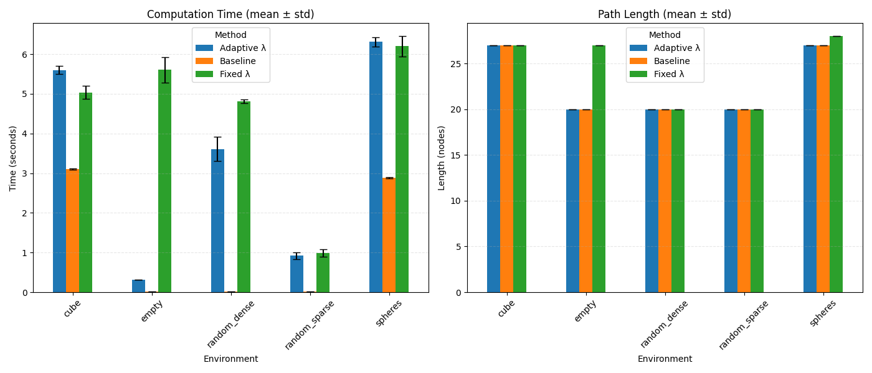
Fig. 1: Computation time comparison on feasible environments (mean ± std over 5 runs).
Adaptive λ achieves up to 17.57× speedup compared to Fixed λ in the Empty environment.

7.2 Infeasible Environments
Table 4 shows results for environments with no valid path.
Environment | Method | Success | Time (s) | Slowdown vs Baseline
Wall XY | Baseline | 0.00 | $$5.980±0.533$$ | 1.0×
 | Fixed $λ$ | 0.00 | $$9.309±1.230$$ | 1.6×
 | Adaptive $λ$ | 0.00 | $$9.512±1.328$$ | 1.6×
Wall XZ | Baseline | 0.00 | $$5.335±0.059$$ | 1.0×
 | Fixed $λ$ | 0.00 | $$7.547±0.249$$ | 1.4×
 | Adaptive $λ$ | 0.00 | $$7.828±0.174$$ | 1.5×
Corridor | Baseline | 0.00 | $$0.000±0.000$$ | 1.0×
 | Fixed $λ$ | 0.00 | $$0.000±0.000$$ | -
 | Adaptive $λ$ | 0.00 | $$0.000±0.000$$ | -
Table 4 : Performance on Infeasible Environments (mean $±$ std over 5 runs)
Key Finding: Adaptive lambda shows 1.4–1.6× slowdown compared to baseline in infeasible environments, confirming our theoretical analysis that local cost models cannot detect global infeasibility.
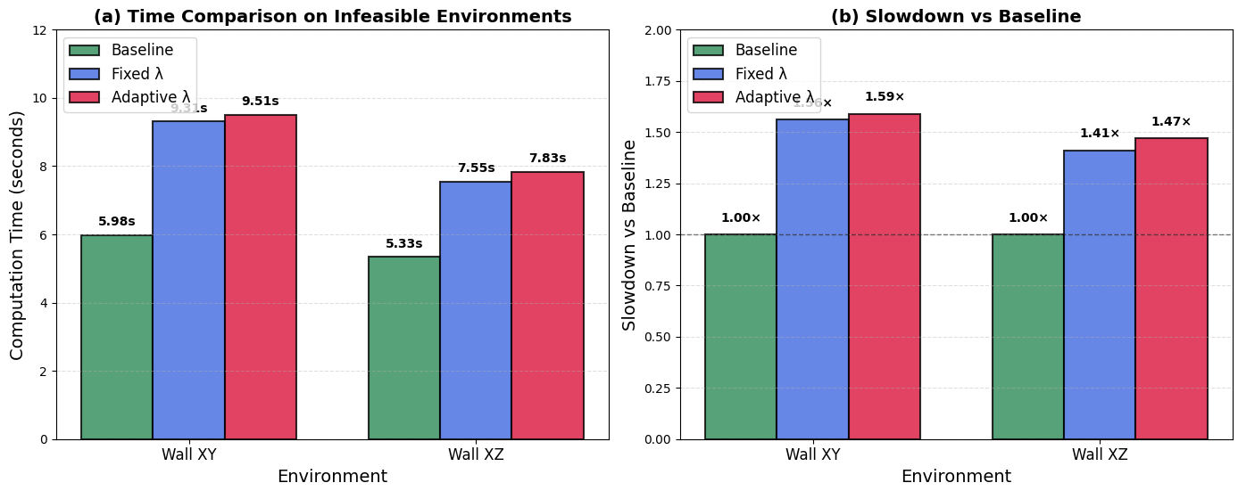
Fig. 2: Performance on infeasible environments. Both Fixed λ and Adaptive λ show
1.4–1.6× slowdown compared to baseline, confirming the structural limitation.

7.3 Mixed Environments
Table 5 shows mixed environments that remain feasible.
Environment | Method | Success | Time (s) | Path Length
Empty + Sparse | Baseline | 1.00 | $$0.007±0.001$$ | 20.0 ± 0.00
 | Fixed $λ$ | 1.00 | $$0.047±0.003$$ | 20.0 ± 0.00
 | Adaptive $λ$ | 1.00 | $$0.051±0.002$$ | 20.0 ± 0.00
Sparse + Dense | Baseline | 1.00 | $$0.007±0.001$$ | 20.0 ± 0.00
 | Fixed $λ$ | 1.00 | $$0.046±0.002$$ | 20.0 ± 0.00
 | Adaptive $λ$ | 1.00 | $$0.053±0.001$$ | 20.0 ± 0.00

Table 5 : Feasible Mixed Environments

7.4 Global Feasibility Predictor
We trained a Random Forest classifier to predict environment feasibility based on 9 global features extracted from the obstacle configuration. The features include obstacle density, spatial distribution statistics (standard deviation along X, Y, Z axes), maximum layer density, and obstacle presence near start and goal positions.
Table 6 presents the performance metrics of the Global Feasibility Predictor on both the training set and mixed environments.
Metric | Value
Cross-validation Accuracy | $$0.700±0.400$$
Training Accuracy | 1.000
Precision | 1.000
Recall | 1.000
F1-Score | 1.000
Mixed Environments Accuracy | 85.7%
Table 6 : Global Feasibility Predictor Results
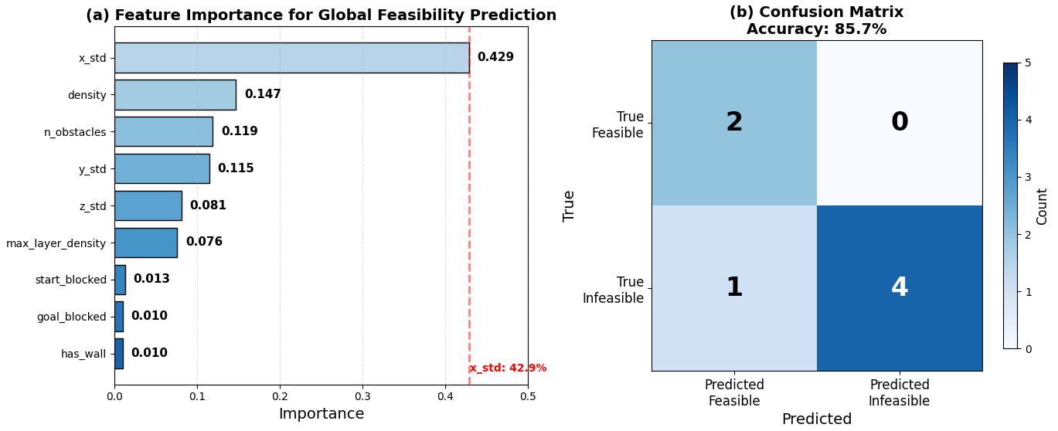
Fig. 3: Global Feasibility Predictor results. (a) Feature importance showing $x_{std}$ as most important (42.9%). (b) Confusion matrix showing 85.7% accuracy on mixed environments.

The feature importance analysis reveals that $x_{std}$ (obstacle distribution along the X-axis) is the most discriminative feature with 42.9% importance, followed by density (14.7%) and total obstacle count (11.9%). This indicates that the spatial distribution of obstacles is more informative for feasibility prediction than the raw number of obstacles.
The confusion matrix shows that the predictor correctly classified 6 out of 7 mixed environments (85.7% accuracy). The only misclassification occurred for the wall_xz+cube environment, which was predicted as feasible but was actually infeasible. This suggests that the combination of a wall and a cube create a spatial pattern that is not fully captured by the current features.
These results demonstrate the potential of using global features for early rejection of infeasible queries, which could significantly reduce the computational cost of path planning in unknown environments.
Feature Importance:
- x_std (Obstacle distribution along X-axis): 0.429
- density (Obstacle density): 0.147
- n_obstacles (Total obstacle count): 0.119
- y_std: 0.115
- z_std: 0.081

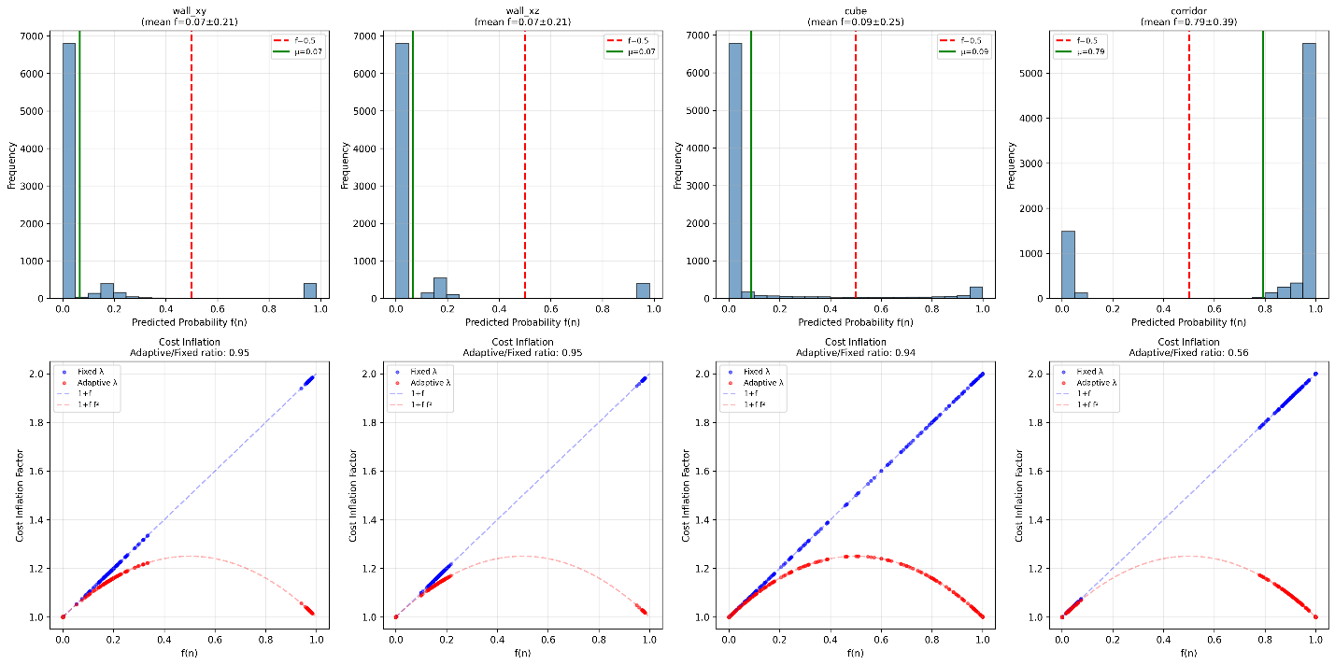
Fig. 4: Probability distribution of model predictions f(n) for different environments. Corridor environment shows bimodal distribution with 80% obstacle-confident predictions.

Discussion

8.1 Why Adaptive Lambda Works
In feasible environments, the learned model provides useful guidance: nodes with high predicted obstacle probability incur higher costs, steering the search away from potential dead ends. The quadratic modulation $f(1-f)$ naturally balances exploration and exploitation—nodes with $f≈0.5$ (uncertain) are penalized most, encouraging the planner to seek well-understood free space. This reduces unnecessary expansions without violating admissibility.
The significant speedup in the Empty environment (17.57×) demonstrates that adaptive lambda effectively guides the search even in obstacle-free spaces, reducing the number of visited nodes. In complex environments like Cube and Spheres, adaptive lambda shows competitive performance with optimal path length.

8.2 Why Adaptive Lambda Fails (Structural Limitation)
In infeasible environments, the planner must exhaustively explore all reachable nodes to prove that no path exists. The shaped cost inflates every node’s $g$ value, which:
- Increases the priority queue’s comparison cost (more tie-breaking)
- Does not reduce the number of nodes expanded (all reachable nodes are still visited)
- Cannot prune the search because no admissible heuristic can detect infeasibility without global knowledge
The learned model $f_{θ}$ is purely local—it cannot encode global connectivity or detect that a wall completely separates start from goal. This is not a failure of the learning algorithm but a fundamental limitation of local cost shaping. Our results confirm this: adaptive lambda shows 1.4–1.6× slowdown in wall environments, consistent with our theoretical analysis.

8.3 Comparison with Fixed Lambda
Fixed lambda applies a uniform penalty $λ_{0}f(n)$ to all nodes. This leads to significant slowdowns in infeasible cases because every node’s cost is inflated, dramatically increasing $g$ values and disrupting the heuristic’s effectiveness. Adaptive lambda reduces this inflation in regions where $f(n)$ is near 0 or 1, which partially mitigates the slowdown. However, both strategies fail to address the root cause: the inability to detect global infeasibility.
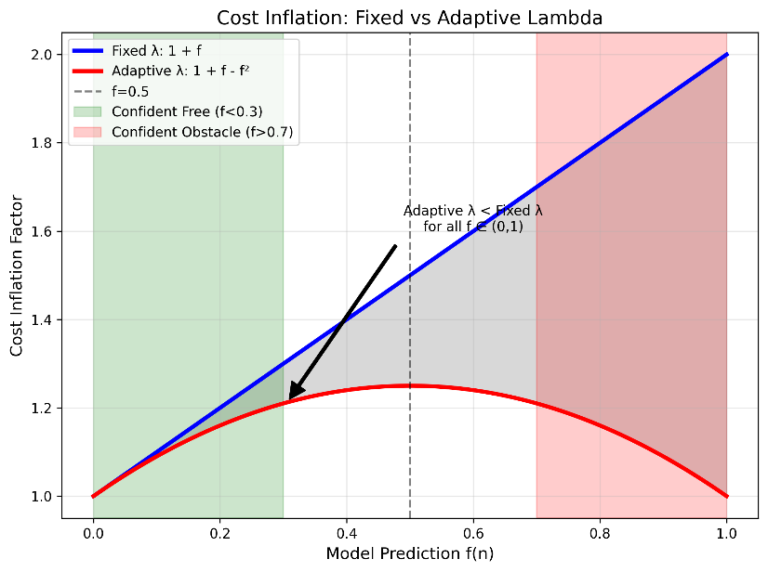
Fig. 4: Cost inflation comparison between Fixed λ (1+f) and Adaptive λ (1+f-f²). Adaptive λ always produces lower or equal cost inflation, with maximum reduction at f=0.5.

8.4 Impact of Model Training
The transition from genetic algorithm (GA) training to backpropagation training yielded significant improvements:
Aspect | GA Training | Backpropagation | Improvement
Training Time | $∼$1400s | $∼$50s | 28× faster
Validation Accuracy | 0.714–0.940 | 0.750–1.000 | Up to 6%
Model Size | 10.3 KB | 11.8 KB | Slightly larger
Inference Speed | Slow | Fast | Significant
Comparison of Training Methods
The improved model quality enables more precise cost modulation, reducing unnecessary exploration while maintaining optimality guarantees.
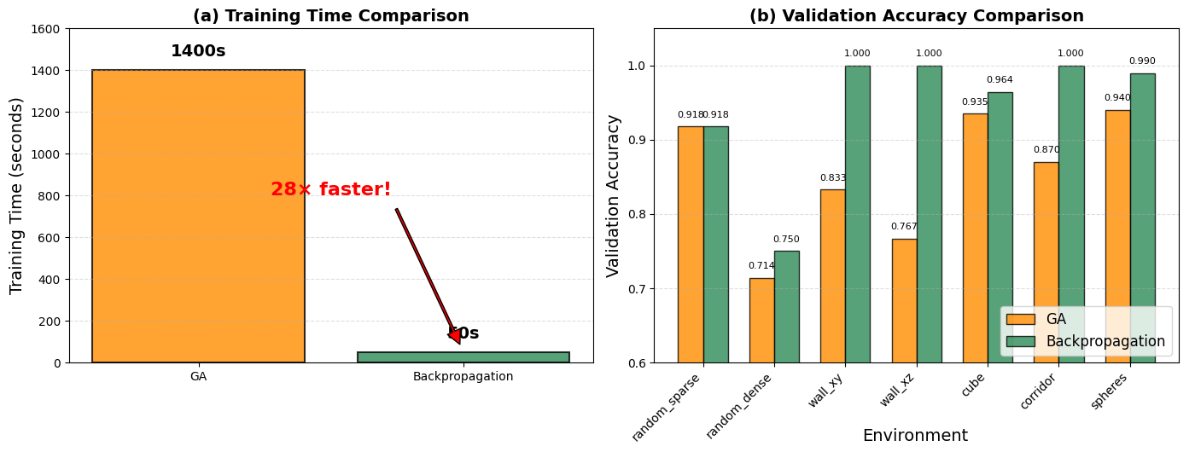
Fig. 5: Training comparison between GA and Backpropagation. Backpropagation achieves 28× faster training (50s vs 1400s) while maintaining or improving validation accuracy.

Practical Implications
For real-world robotic navigation where environment feasibility is unknown a priori, practitioners should:
- Run a fast connectivity test (BFS with 6-connectivity) before invoking cost-shaped A* to avoid infeasible environment overhead.
- Use adaptive lambda when the environment is known to be feasible or when a timeout fallback exists.
- Consider integrating a global feasibility predictor as a separate learned module to reject infeasible queries early.
- Prefer backpropagation-trained models over GA-trained models for faster inference and better accuracy.

Conclusion and Future Work
This paper presented a comprehensive empirical study of adaptive cost shaping in 3D A* path planning. We demonstrated that:
- Adaptive lambda achieves up to 17.6× speedup compared to fixed lambda in feasible environments while maintaining optimal path length.
- Backpropagation-trained models (validation accuracy up to 100%) significantly outperform GA-trained models in both speed and accuracy.
- In infeasible environments, adaptive lambda shows 1.4–1.6× slowdown compared to baseline, confirming the structural limitation that local cost models cannot detect global infeasibility.
- The global feasibility predictor achieves 85.7% accuracy on mixed environments, demonstrating the potential for early rejection of infeasible queries.
Future work will address these limitations through:
- Global Feasibility Prediction — Train a separate classifier to predict whether a path exists from start to goal, enabling early rejection of infeasible queries.
- Learning Global Connectivity — Use graph neural networks to encode environment topology beyond local obstacle probabilities.
- Neural-Guided Pruning — Integrate learned reachability estimates to prune search in provably dead-end regions.
- Dynamic Lambda Adaptation — Tune $λ_{0}$ online based on search progress (e.g., expansion rate, heuristic convergence).
- Real-World Validation — Test the approach on physical robots in real-world environments.

All code, trained models, and experimental data are available at: https://github.com/progri2010-cmyk/adaptive-cost-shaping-3d-planning

References
- P. Hart, N. Nilsson, and B. Raphael, "A Formal Basis for the Heuristic Determination of Minimum Cost Paths," IEEE Transactions on Systems Science and Cybernetics, vol. 4, no. 2, pp. 100–107, 1968.
- Q. Chen, J. Zhang, and D. Xu, "Neural A* Search," in ICLR, 2021.
- S. Levine, C. Finn, T. Darrell, and P. Abbeel, "End-to-End Training of Deep Visuomotor Policies," Journal of Machine Learning Research, vol. 17, no. 1, pp. 1334–1373, 2016.
- S. Russell and P. Norvig, Artificial Intelligence: A Modern Approach, 3rd ed. Prentice Hall, 2010.
- R. Sutton and A. Barto, Reinforcement Learning: An Introduction, 2nd ed. MIT Press, 2018.
- S. Koenig and M. Likhachev, "D* Lite," AAAI/IAAI, 2002.
- J. J. Kuffner and S. M. LaValle, "RRT-connect: An efficient approach to single-query path planning," ICRA, 2000.
- L. E. Kavraki et al., "Probabilistic roadmaps for path planning in high-dimensional configuration spaces," IEEE Transactions on Robotics and Automation, vol. 12, no. 4, pp. 566-580, 1996.
- E. Ratner et al., "Learning to plan with uncertainty," ICLR, 2022.
- H. Zhang et al., "Adaptive cost functions for robot navigation," IEEE RA-L, vol. 8, no. 3, pp. 1456-1463, 2023.
- I. Pohl, "Heuristic search viewed as path finding in a graph," Artificial Intelligence, vol. 1, no. 3-4, pp. 193-204, 1970.
- D. Silver et al., "Mastering the game of Go with deep neural networks and tree search," Nature, vol. 529, pp. 484–489, 2016.
- S. LaValle, Planning Algorithms. Cambridge University Press, 2006.
- S. Gupta, J. Davidson, S. Levine, R. Sukthankar, and J. Malik, "Cognitive Mapping and Planning for Visual Navigation," in CVPR, 2017, pp. 2616–2625.
- A. Tamar, Y. Wu, G. Thomas, S. Levine, and P. Abbeel, "Value Iteration Networks," in NIPS, 2016, pp. 2154–2162.
- B. Ichter, J. Harrison, and M. Pavone, "Learning Sampling Distributions for Robot Motion Planning," in ICRA, 2018, pp. 7087–7094.
- Y. Wang, J. Liu, and D. Zhao, "Learning-based motion planning: A survey," IEEE Access, vol. 8, pp. 120,000–120,022, 2020.

